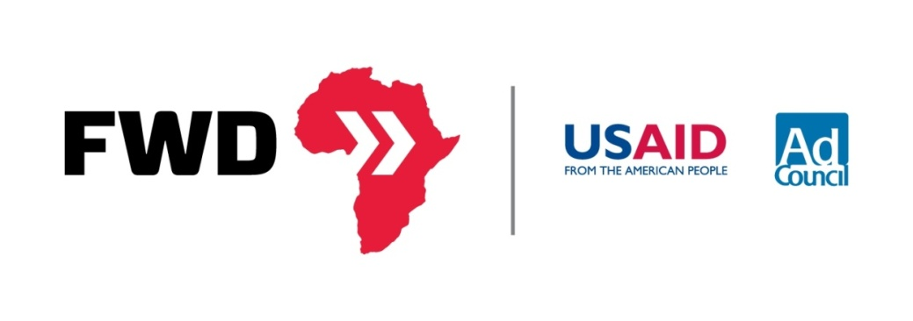

Host a House Party: Horn of Africa Humanitarian Crisis
The worst drought in 60 years has devastated communities throughout the Horn of Africa, leaving more than 13 million people in crisis. Help spread awareness about this crisis and why it’s different by hosting a house party about the Famine.
- Choose a Date
- Invite your Family, Friends, Coworkers, and Peers
- Download our community organizing kit
At the event:
- Show the Video Playlist from USAID’s Horn of Africa YouTube Playlist.
- Show people the USAID.gov/FWD website and explain the infographics to the group
- Let people know about the text to donate campaign but also see if people can log into their facebook accounts at the party and post their favorite infographic to their wall through the FWD Facebook tab.
- At the end consider having the group record their own 15-30 second public service announcement and upload it to youtube then tweet it out #FWD. Download a sample script from the FWD website.
Quick Facts:
FACT: The famine in the Horn of Africa is currently affecting over 13 million people.
FACT: Instability and conflict have forced over 700,000 Somalians to flee their homes for refugee camps hundreds of miles away.
FACT: The Horn of Africa is experiencing its worst drought in over 60 years.
FACT: 1 Somalian child dies every 6 minutes.
FACT: Not enough people are talking about this crisis.

Visit USAID.gov/FWD to forward the facts.

