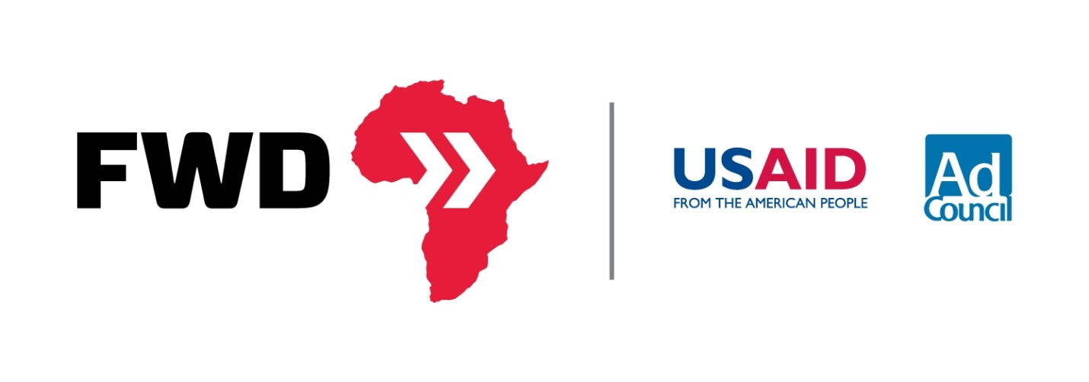
FWD Louder: Amplifying Awareness around the Horn of Africa
A Guide to Writing to your Local Paper
An op-ed or letter to the editor can be an effective way to raise awareness for the Horn of Africa crisis. Here is a brief guide to help you send a thought provoking, action inspiring message about the humanitarian crisis.
Table of Contents
Themes 3
A collection of suggested titles and themes to get you started as you write. 3
Facts 4
More facts are available at usaid.gov/fwd or #FWD 4
Write a Letter to the Editor 5
What is a Letter to the Editor? 5
A Sample Letter to the Editor 5
Write an Op-Ed 6
What is an Op-Ed? 6
A Sample Op-Ed 6

Themes
A collection of suggested titles and themes to get you started as you write.
Horn of Africa Crisis—Who is Watching?
Challenge students to ask themselves why awareness is so low for the Horn of Africa Crisis.
Do You Know where the Horn of Africa Is?
Help readers place this crisis on a map, giving it a size, scope, and face.
Would you Walk 100 Miles for Food?
Ask readers to place themselves in the shoes of a Somali refuge fleeing the famine today.
13 Million Affected by Drought and Famine
Hit readers with the harsh facts of the famine—showing how widespread this crisis really is.
Drought and Famine—Does One Lead to Another?
Explore the question of whether or not drought must inevitably lead to famine in the context of the Horn of Africa crisis.
New York and Los Angeles Face Famine. Big Deal?
Catch the reader’s eye by offering a more tangible example—the number of people affected by the famine is more than the combined populations of New York and Los Angeles.
Crisis Response—Why Location Matters
Ask the question of location. Why did the smaller scale crisis in Haiti and Indonesia garner so much greater public outcry than this
Famine + War + Drought = Crisis
Highlights the factors - Famine, War, and Drought- played in the escalated Horn of Africa crisis.
Famine in the Horn of Africa: Why don’t we know about this?
As another means of challenging the public consciousness, this theme is a great way to begin the discussion around awareness for the Horn of Africa in the United States.
“Drought comes from God, but famine comes from Man”
Use this common Kenyan saying to ignite discussion about why famine has been declared in Somalia but not in Kenya and Ethiopia.

Facts
- Odds that a Somali child will die before his or her fifth birthday – 1 in 7.4. www.usaid.gov/FWD #FWD
- Dadaab Refugee Camp in Kenya, established in ’91, was built to hold 90k refugees: it currently hosts over 450k. #FWD www.usaid.gov/FWD
- Drought does not have to lead to famine. #FWD www.usaid.gov/FWD
- This year’s cereal crop in Somalia is the lowest in 17 years, sending prices soaring 300% #FWD www.usaid.gov/FWD
- USAID-supported early warning systems alerted of pending crisis, allowing USAID to preposition supplies. #FWD www.usaid.gov/FWD
- More than 13 million people are in crisis in the Horn – making this the largest humanitarian crisis in the world. www.usaid.gov/FWD #FWD
- 700,000+ Somalis have fled from their homes into Ethiopia and Kenya- many walking 100 miles for food #FWD www.usaid.gov/FWD
- In developing countries, 1 of every 4 children under 5 is underweight. www.usaid.gov/FWD #FWD
- Feed the Future is a $3.5 billion pledge from the US to work with countries and stakeholders to tackle food challenges. #FWD www.usaid.gov/FWD
- Feed the Future will leverage $70 billion in private investment in ag to help markets and small farmers. #FWD www.usaid.gov/FWD
- The world’s population is projected to increase to nine billion by 2050, requiring a 70% increase in ag production. #FWD www.usaid.gov/FWD
- 2.5 billion in aid is needed for the crisis in the Horn. To date, the global community has contributed nearly $2 billion. #FWD www.usaid.gov/FWD
- The leading cause of death in past famines has been preventable disease. www.usaid.gov/FWD #FWD
- U.S. has provided nearly $650 million in emergency assistance that is helping 4.6Mpeople in the Horn. www.usaid.gov/FWD #FWD
- The Horn of Africa is facing the world’s worst drought in 60 years and the worst famine in 20. www.usaid.gov/FWD #FWD
- Without aid, 750,000 Somalis are projected to perish from starvation by the end of 2011. #FWD www.usaid.gov/FWD

More facts are available at usaid.gov/fwd or #FWD

Write a Letter to the Editor

What is a Letter to the Editor?
A letter to the editor is a way for the public to quickly and easily voice their concerns in a simple letter format. Be short and concise when writing. Letters to the Editor are typically less than 150 words. To publish a letter to the editor, check local publications for their guidelines and submission information.

A Sample Letter to the Editor
Dear Editor,
I am alarmed by the calamity currently transpiring in the Horn of Africa, but am equally alarmed by the fact that no one seems to know about it. For readers who aren’t aware, I forward the facts.
Right now, the Horn of Africa (Eastern Africa) is experiencing the worst drought in 60 years. In Somalia—where twenty years of war and violence has limited humanitarian access—the drought has led to famine. As a result, a child is dying in Somalia every six minutes. Left with nothing, many are walking more than 100 miles toward refugee camps in Kenya and Ethiopia.
I’m encouraged by the U.S. Feed the Future initiative which is addressing the root causes of food insecurity, but this crisis demands us all. I urge people to visit usaid.gov/FWD to get the facts and forward them to your networks.
We are the relief.

Write an Op-Ed

What is an Op-Ed?
An op-ed is an opinion article, often published in a newspaper or online publication, written by members of the public. Op-eds give writers an opportunity to share individual thoughts on a particular topic. They should be easy to read and engaging—typically between 750 and 1000 words. Keep the following in mind when writing:
- Demonstrate your personal connection to the issue.
- Do not use make a claim that you cannot prove.
- Be timely—capitalize on recent news and events.
- Keep the op-ed focused—stick to a single subject.
- Check the publication’s guidelines for word limits and submission information
- Avoid technical terms and verbosity – use simple sentence structure.

Sample Op-Ed: Cross-posted from the Harvard Crimson

750,000 Could Die in Somalia
By Ravi N. Mulani
Hundreds of Somalis are dying everyday. 750,000 will die over the next few months if the international community does not take dramatic action to help ease the suffering due to the East African famine. Thirteen million people throughout East Africa are in need of emergency help, and four million are living through the worst famine in 20 years.

More people are at risk of death than in the combination of the Japanese Earthquake, the Libyan Civil War, and catastrophic American weather events of 2011, but the international community has not done nearly enough to help. East Africa is experiencing a famine of epic proportions, and the global community can do much more.

The crisis is a long time in the making, and has been spurred on by a variety of environmental and political factors. It was induced by a drought that is the worst in 60 years and has been exacerbated by the political situation in Somalia, perhaps the world’s most dysfunctional failed state. The nominally democratic government in the north of the country is extremely weak, and though it lets in foreign aid it also loots and steals the food aid. The extremist al-Shabab government in the south refuses to let foreign aid into its regions, leaving its residents with few options other than to flee to overloaded refugee camps in Kenya.

The failed state exists in a large part because of a lack of attention from the international community. As Nicholas D. Kristof recently wrote, it is no coincidence that the famine is hitting Somalia, a country with no functioning institutions, much harder than it is hitting countries like Kenya and Ethiopia, where sophisticated famine warning systems and strong agricultural institutions have cushioned them against the worst of the famine.

We can learn a useful long-term lesson from this famine about the necessity of working with the global community to help build functional states in chaos-torn areas, but right now there is little time to dwell on long-term foreign policy goals. Every day hundreds of Somalis are dying, and this issue must become an urgent, front-page priority.

According to USAID, more people are at risk than the combined populations of New York City and Los Angeles. In Somalia, one child dies every six minutes. The U.N. has estimated that $2.5 billion is needed in aid to fight the immediate crisis; until now the international community has donated $1.7 billion, with $600 billion coming from the United States.

The aid needs become more dire every day, but even ordinary students can help in meaningful ways. Donating $10 to the consortium of charities linked at usaid.gov/fwd can feed a family of six for two days.

Given the fact that the Al-Shabab are not even allowing foreign aid workers into south Somalia, some might see donating further to efforts as futile. However, much of the care goes to fleeing Somalis in Kenyan refugee camps, as well as to families fleeing into Mogadishu, and is undertaken by foreign aid groups. As a country, we have both the compassion and the power to make an even greater difference in this famine, and regardless of whether others do, we should.

The world is facing its most urgent humanitarian crisis in decades, and there is a great amount to do to help out. Donate to feed a family right now; tell all your friends about the issue. Whether in the Japanese Earthquake, the earthquake in Haiti, or the tsunami in Indonesia, the American people and their government have been leaders in foreign disaster response. In a crisis where hundreds of children and their families are starving everyday, there is an urgent need for Americans to much more aggressively lead the response.

Ravi N. Mulani ’12, a Crimson editorial writer, is an applied mathematics concentrator in Winthrop House.

