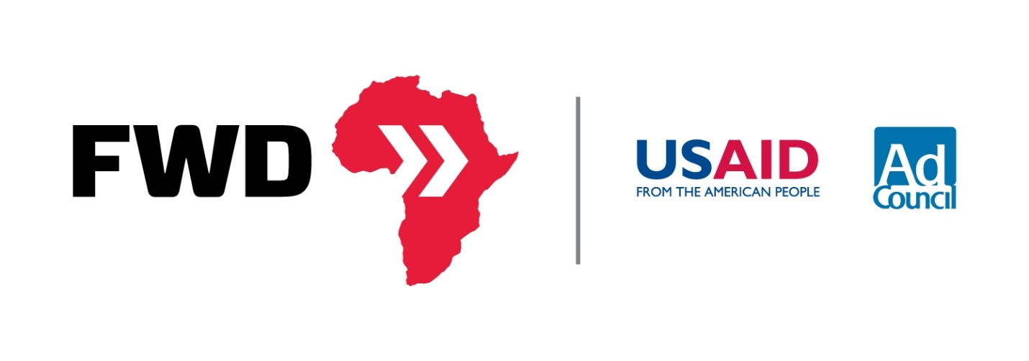
FWD Louder: Amplifying Awareness around the Horn of Africa
A Guide to Blogs
A blog entry can be an effective way to raise awareness for the Horn of Africa crisis. Here is a brief guide to help you send a thought provoking, action inspiring message about the humanitarian crisis.
Table of Contents
Themes 2
A collection of suggested titles and themes to get you started as you write. 2
Facts 3
More facts are available at usaid.gov/fwd or #FWD 3
Write a Blog Post 4
Embed Crisis Maps and Infographics into your Post 4
A Sample Blog Post: Take a look below at this example from the USAID Impact Blog. 5

Themes
A collection of suggested titles and themes to get you started as you write.
Horn of Africa Crisis—Who is Watching?
Challenge students to ask themselves why awareness is so low for the Horn of Africa Crisis.
Do You Know where the Horn of Africa Is?
Help readers place this crisis on a map, giving it a size, scope, and face.
Would you Walk 100 Miles for Food?
Ask readers to place themselves in the shoes of a Somali refuge fleeing the famine today.
13 Million Affected by Drought and Famine
Hit readers with the harsh facts of the famine—showing how widespread this crisis really is.
Drought and Famine—Does One Lead to Another?
Explore the question of whether or not drought must inevitably lead to famine in the context of the Horn of Africa crisis.
New York and Los Angeles Face Famine. Big Deal?
Catch the reader’s eye by offering a more tangible example—the number of people affected by the famine is more than the combined populations of New York and Los Angeles.
Crisis Response—Why Location Matters
Ask the question of location. Why did the smaller scale crisis in Haiti and Indonesia garner so much greater public outcry than this
Famine + War + Drought = Crisis
Highlights the factors - Famine, War, and Drought- played in the escalated Horn of Africa crisis.
Famine in the Horn of Africa: Why don’t we know about this?
As another means of challenging the public consciousness, this theme is a great way to begin the discussion around awareness for the Horn of Africa in the United States.
“Drought comes from God, but famine comes from Man”
Use this common Kenyan saying to ignite discussion about why famine has been declared in Somalia but not in Kenya and Ethiopia.

Facts
- Odds that a Somali child will die before his or her fifth birthday – 1 in 7.4. www.usaid.gov/FWD #FWD
- Dadaab Refugee Camp in Kenya, established in ’91, was built to hold 90k refugees: it currently hosts over 450k. #FWD www.usaid.gov/FWD
- Drought does not have to lead to famine. #FWD www.usaid.gov/FWD
- This year’s cereal crop in Somalia is the lowest in 17 years, sending prices soaring 300% #FWD www.usaid.gov/FWD
- USAID-supported early warning systems alerted of pending crisis, allowing USAID to preposition supplies. #FWD www.usaid.gov/FWD
- More than 13 million people are in crisis in the Horn – making this the largest humanitarian crisis in the world. www.usaid.gov/FWD #FWD
- 700,000+ Somalis have fled from their homes into Ethiopia and Kenya- many walking 100 miles for food #FWD www.usaid.gov/FWD
- In developing countries, 1 of every 4 children under 5 is underweight. www.usaid.gov/FWD #FWD
- Feed the Future is a $3.5 billion pledge from the US to work with countries and stakeholders to tackle food challenges. #FWD www.usaid.gov/FWD
- Feed the Future will leverage $70 billion in private investment in ag to help markets and small farmers. #FWD www.usaid.gov/FWD
- The world’s population is projected to increase to nine billion by 2050, requiring a 70% increase in ag production. #FWD www.usaid.gov/FWD
- 2.5 billion in aid is needed for the crisis in the Horn. To date, the global community has contributed nearly $2 billion. #FWD www.usaid.gov/FWD
- The leading cause of death in past famines has been preventable disease. www.usaid.gov/FWD #FWD
- U.S. has provided nearly $650 million in emergency assistance that is helping 4.6Mpeople in the Horn. www.usaid.gov/FWD #FWD
- The Horn of Africa is facing the world’s worst drought in 60 years and the worst famine in 20. www.usaid.gov/FWD #FWD
- Without aid, 750,000 Somalis are projected to perish from starvation by the end of 2011. #FWD www.usaid.gov/FWD

More facts are available at usaid.gov/fwd or #FWD

Write a Blog Post

Embed Crisis Maps and Infographics into your Post
USAID.gov/fwd/crisis has a series of embeddable maps you can use within blog posts. In addition, info-graphics are available to be embedded as well at USAID.gov/fwd. Finally the buttons below also have embed links to link your blog to the FWD campaign.

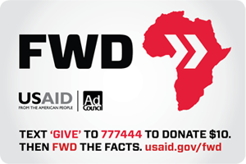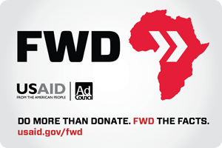

Widget 1 Embed Link Widget 2 Embed Link

A Sample Blog Post: Take a look below at this example from the USAID Impact Blog.

FWD the Facts about Famine, War, and Drought in the Horn of Africa
Posted by Rajiv Shah on September 20, 2011
As many of you know, the worst drought in 60 years has devastated communities throughout the Horn of Africa, leaving more than 13 million people in a state of crisis—greater than the population of Los Angeles and New York combined.
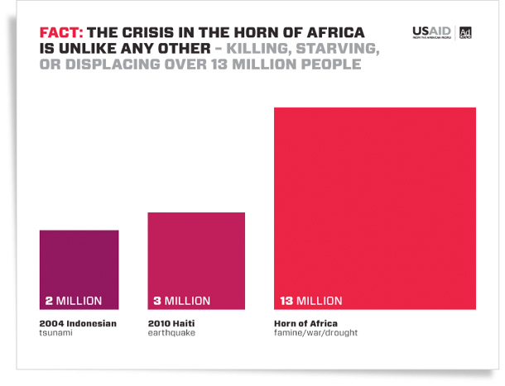
In Somalia—where twenty years of war and violence has limited humanitarian access and destroyed the country’s ability to respond—the drought has led to an outbreak of famine. According to UNICEF, as a result of this crisis, a child is dying in Somalia every six minutes.
The millions suffering from the effects of this crisis are facing incomprehensible suffering. Left with nothing, many are walking more than 100 miles toward refugee camps in Kenya and Ethiopia.
Because the crisis in the Horn is so complex and because the scale is so difficult to comprehend, we have not seen people come together to respond in the same way they did after the earthquake in Haiti. Many who do hear about the crisis are left with the impression that we can’t successfully do anything about it.

But I know for a fact that we can fight this famine. We were fighting it before it started. Through safety net programs, we have helped 7.5 million Ethiopians withstand the worst effects of this drought without the need for humanitarian assistance.
And as a result of Feed the Future investments, we have seen more than a 300 percent increase in grain yields in Western Kenya in just one year, securing the nation’s agricultural backbone and helping lower the price of critical staples throughout the region.
But despite being the single largest donor of assistance in the region, we recognize we cannot fight the famine alone.
That’s why today, I’m announcing the launch of the FWD Campaign—in partnership with the Ad Council—to highlight the uniquely devastating nature of this crisis and to ask people to help spread awareness.
FWD—stands for Famine, War, Drought: the three major crises that have led to this perfect storm of devastation in the Horn of Africa. But it also stands for our call to action—that people get informed, get engaged and forward this information on to their friends and families.
The FWD campaign is our attempt to make our world smaller—to connect people with the clear knowledge and understanding of exactly what is happening in the Horn—and giving them a powerful way to respond.
The campaign has three components. One is an effort that’s centered on using a strong online presence and social media to raise awareness. If you go to USAID.gov/FWD, you’ll see a number of new ways we’re using to inform and engage with people. We’re providing infographics, interactive maps and tool kits that people can use to learn about the crisis in simple, clear ways—and more importantly share that information others. And we’re partnering with Google, Facebook and Twitter to make sharing this information as easy as searching, updating your status or sending out a tweet.
Learn more about how you can get involved on the IMPACTblog.

Dr. Rajiv Shah is Administrator of the United States Agency for International Development

